1. What is Boolean? Write down 3 different expression that results a Boolean type (i.e. 5 == 6)
2. What is a flow chart? Draw flow chart for the following code snippet: (you can draw on a paper, take a picture of it)

if name == “Huy be":

print(“Hand some")

elif name == “Huy big":

even_more_handsome = True

else:

webbrower.open(“<https://www.youtube.com/watch?v=04854XqcfCY>”)

1. What is nested conditionals? Write a piece of code that uses nested conditionals

Answer:

* + - 1. A Boolean value is either true or false and a Boolean expression is an expression that evaluated to produce the value which is a Boolean value.

Eg: 6 == 3 + 3; 5 == 7;

J = “wo”

L= “oh”

J + L == “wooh”

True

2. A flow chart is a diagram of the sequence of steps to make something done.

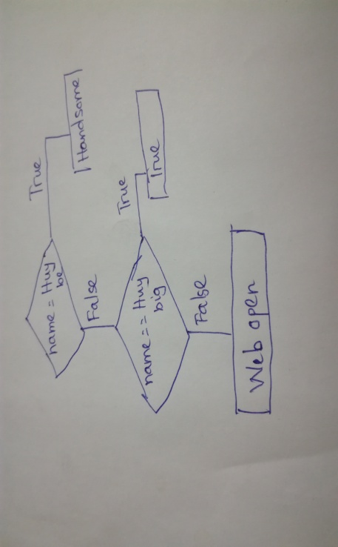

3. Nested conditional is a condition that are defined with other conditions.

if x > y

print("Chuan men")

else:

if x > y

print("Gay")

else:

print("Less")